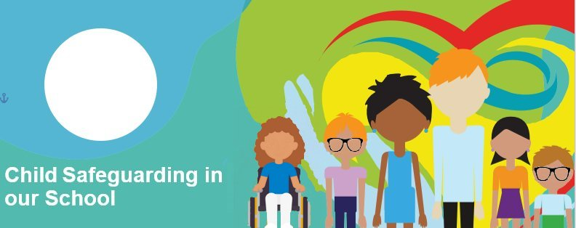


Child safeguarding is what we do in our school to keep children and young people safe from harm.

We teach the Stay Safe Programme to help you feel safe at school and in your life outside of school too.

We also think about other ways to keep everyone safe and we write these down. This is called our Child Safeguarding Statement.

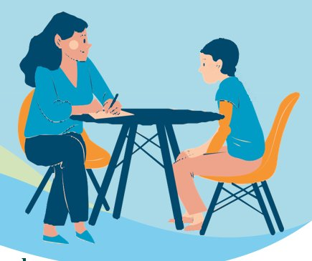
We check this every year. When we do this we will ask you what you think about safeguarding in our school.

If someone says or does something to hurt you or makes you feel uncomfortable, you can tell an adult that you trust.
What we will do:
- Listen and understand
- Guide or look for help

Who to go to:
- Any trusted adult
For example, a teacher, SNA, secretary/caretaker or the principal



Every school has a person in charge of child safeguarding. This person is called the Designated Liaison Person or DLP. The DLP for our school is Mr Roarty
Name and photo

